Application Form For Arbitrators

Name:
Date:

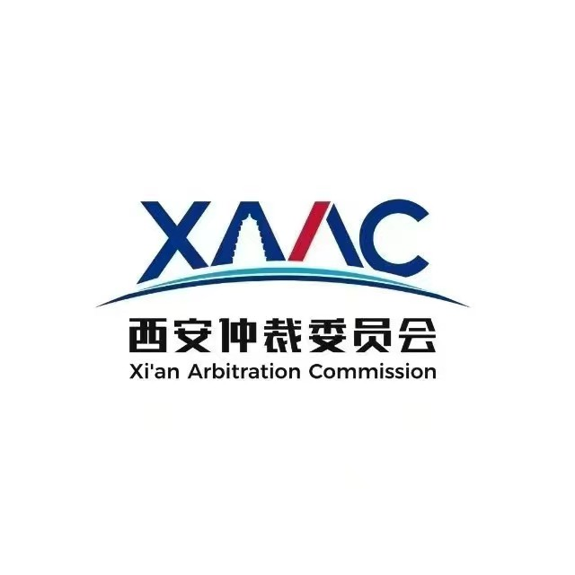

西 安 仲 裁 委 员 会
Xi’an Arbitration Commission

Basic Personal Information
First Name: | Middle Name: |  | Recent photo  (2-inch)
Last Name: | Gender: |  | Recent photo  (2-inch)
Nationality: | Passport No.: |  | Recent photo  (2-inch)
Date of Birth: | Professional Title: |  | Recent photo  (2-inch)
City of Residence:
Practice Location(s):
Present Employment: |  | - Academic x  - Legal professionx  - Commercial Business  - Government Official  - Others：________
Position:
(For Lawyer Only)Jurisdiction(s) of Admission:
Concurrent employment(if any): |  | - Academic  - Legal profession  - Commercial Business  - Government Official  - Others：________
Position:
Concurrent employment(if any): |  | - Academic  - Legal profession  - Commercial Business  - Government Official  - Others：________
Position:

Contact Information
Mobile Number: (+ )
Office Number: (+ )
Fax Number: (+ )
Email:

Correspondence Address:
Preferred Courier Company:□DHL □UPS □EMS □Others (please specify) □ No preference
Arbitration Experience
Number of nominations/appointments in which institution/ad hoc

Qualifications /Memberships (e.g. SIAC, ICC, HKIAC, LCIA)

Professional Specialty
Please use Key words and rank them according to capability. The first 2 will be published in Panel of Arbitrators.
Working Experience
Professional Career |  |  | Position | Starting Year |  | Ending Year
1
2
3
4
Publications(if any)
Title of Publication |  |  |  |  | Year
1
2
3
4

Language Skills
Languages |  | Level of Fluency |  |  | Ability to Write
1 |  | □Native □Fluent □Good □Basic |  |  | □ Yes □ No
2 |  | □Native □Fluent □Good □Basic |  |  | Yes □ No
3 |  | □Native □Fluent □Good □Basic |  |  | □ Yes □ No
4 |  | □Native □Fluent □Good □Basic |  |  | □ Yes □ No
Education Background
Name of University |  |  | Degree Obtained | Year of Enrollment |  | Year of Graduation
1
2
3
4

Declarations

1. I hereby confirm all the information given before in support of the application is accurate and complete.
2. I have never been found guilty by a court or disciplinary tribunal of misconduct.
3. I understand and authorize XAAC to use my data and my data will become part of XAAC's files and may be used for purposes deemed useful by XAAC.
4. I promise to be neutral, independent and impartial while acting as an arbitrator.
5. I confirm that I am familiar with and will adhere to XAAC's Arbitration Rules and Rules for Arbitrators.

Please sign below to confirm your agreement to the declarations above.

Signature:_______________
Date:_______________

